Conway Parks & Recreation Department

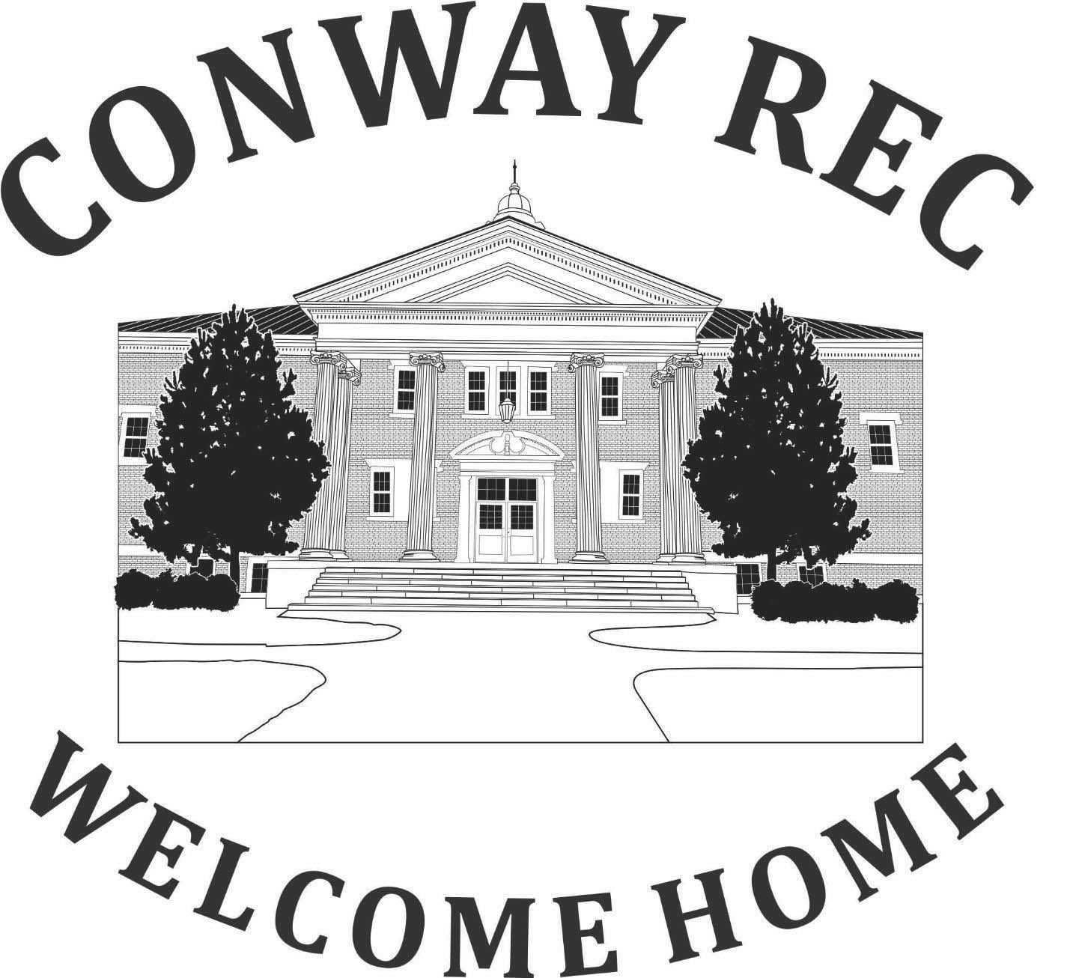

Chip Kennett Teen Center Handbook

Welcome,
Thank you for choosing the Conway Parks & Recreation Department as your child's route to after-school fun. We will work hard to give your child a great Chip Kennett Teen Center experience.
The full-time staff consists of Lauren Kidder (Teen Center Coordinator), Meghan Livingston (Programmer), Michael Lane (Director), Robby Moody (Assistant Director), and Lynore Wagner (Administrative Assistant).
Your child's safety and well-being remain our number one priority. In an effort to keep your teen safe as well as our staff, we will be following guidance and recommendations from the New Hampshire Parks & Recreation Association and the National Parks & Recreation.
Please review our handbook carefully to familiarize yourself with all our policies and procedures. It is assumed that once you have reviewed the handbook, you will comply with all of the guidelines contained in and presented in it.
We hope your child's experience with us is positive and one with lasting memories.
Conway Parks & Recreation Department Staff

Teen Center Description
The Teen Center is open to all children who reside in Conway, Albany, and Eaton in grades 6th-8th.

A wide variety of activities and field trips are planned for your child this year. Please be advised that our schedule is subject to change. The schedule is posted in the monthly newsletter as well as on our website.

The facilities used during the year are Conway Parks & Recreation building, fields, trails, playground, Saco River, Swift River, Kennett Middle School, and off-site field trips.

Cell phones are prohibited at the Teen Center. Each Teen Center member is required to sign in and place their cell phone in the bucket. Need to reach your teen or pick up during operating hours? Call the Teen Center Cell Phone, and a staff member will be able to assist you. The phone number for the Chip Kennett Teen Center is 603-662-6733.

If calling outside of Teen Center hours, the phone number for the Conway Parks & Recreation Department is 901-1139 /901-1141. An answering machine is on 24 hours a day, so you can leave your message there at any time.

If you have any questions or concerns, you can contact the Chip Kennett Teen Center Coordinator, Lauren Kidder.

STAFF
The staff is comprised of very talented and responsible adults/high school students. All staff are certified in CPR and First Aid, and are required to attend training where they are familiarized and educated in conflict resolution, field trip safety, proper supervision, proper etiquette, games, liability, and police training of New Hampshire law and RSA. Staff is required and have cleared an extensive background check.
OUR MISSION
To create and sustain a physically and emotionally safe community-oriented environment that fosters healthy development by providing access to a variety of meaningful activities, self-enhancement programs, and positive role models.
WHAT WE ARE NOT
We are not a daycare or babysitting service. We are not the public school system. Enrollment in this program is a privilege. We try very hard to keep children in this program because we recognize the importance of these activities to children. However, children who present constant or unmanageable behavior problems, make life difficult for other children and /or staff, take away from the overall program, or create safety risks due to their behaviors, are not welcome in this program (please refer to the discipline policy and procedures section of this handbook for specific guidelines). Our staff are after-school counselors, not teachers or psychologists, and cannot provide one-on-one care.
- Sharing information about your child can be critical to their success in the program. Examples are if they have IEPs in school or a one-on-one aide.
- Teens who are suspended from school may not attend the Teen Center.
TRANSPORTATION
Transportation to all locations will be provided by the Conway Parks & Recreation Bus, Van, and Town Car or by walking. Drivers are fully trained and licensed. All vehicles are in good condition and repair. Transportation to and from the Teen Center is the responsibility of the parent/guardian.
LOST & FOUND
Items left at the end of the day will be placed in our lost and found bin located at the side door drop-off entrance. If items are not claimed within 48 hours of being found they will be disposed of. Call Lauren and see if any items are left behind and coordinate a time to come and retrieve lost items.
MEDICATIONS/ALLERGIES

While registering, please remember to view and update your teens’s medical information regarding any new medications/allergies that may affect day-to-day activities (i.e., peanuts, EpiPen, inhaler). Reach out to the office at 603-901-1139 if you are having any trouble adjusting your account information.

WWHHAT NOT TO BRING

To ensure the enjoyment, safety, and health of all children in attendance, the following items are prohibited from Teen Center:
- Money above $20
- *Illegal substances
- *Vapes
- *Knives
- *Fireworks or any type of explosive device*
- Firearms {Toy or Real)
- Phones

Teen Center Members are not permitted to carry cell phones while the Teen Center is in session. If brought to the Teen Center, they will be asked to place them in the phone bucket at the entrance. Children who violate this policy will have their phones confiscated and returned to the bucket. If you need to contact your child, please call the Teen Center phone at 603-662-6733, and a staff member will assist you. Once again, the Conway Parks & Recreation Department is not responsible for lost or stolen cell phones/electronics.
*Denotes immediate expulsion from the Chip Kennett Teen Center for the remainder of the year.

PAYMENT
Payment must be made prior to your child attending Teen Center. We do offer scholarships and payment plans, but parents must see/speak with Lauren Kidder, Teen Center Coordinator, or Lynore Wagner, Administrative Assistant.

CHIP KENNETT TEEN CENTER HOURS

Wednesday: 2:15 PM - 6:30 PM
Wednesday PLC HOURS: 12:15 PM - 6:30 PM
Thursday: 5:00 PM 8:30 PM (Concession Stand)
Friday: 5:00 PM - 9:00 PM
Saturday: 12:30 PM - 4:30 PM
-Times change, and date exclusions will occur due to special events and field trips. Please read the monthly newsletter for these changes/exclusions.
CHECK-IN/CHECK-OUT PROCEDURE
Curbside Drop Off/Check In: Parents will drop their child off each day to staff waiting at the side door entrance. Staff is directed to not release children to anyone they do not know. You (or whoever comes to pick up your child) may be asked to show a form of identification before they are allowed to pick up your child. This ensures that each child is coming and leaving with who he/she should be. If a special situation exists, or in case of an emergency, please speak to Lauren Kidder, Teen Center Coordinator. In addition, if restraining orders or custody decrees by the court are in place, please speak to staff immediately.

Teen Responsibilities

Each evening that they attend, teens are expected to sign up for a “job” to help keep the Teen Center safe, clean, and welcoming. Cooking duties will rotate nightly, while other jobs—such as cleaning and organizing the gym, lounge, game room, library, and cafeteria—are available for teens to choose. Jobs must be completed before leaving for the evening. If a job is not completed, the teen will be assigned both that job and cooking duty the next evening they attend and must check in with the Teen Center Coordinator before leaving. The Coordinator will determine whether the jobs have been completed appropriately. These responsibilities help teens build accountability, contribute to the community, and take ownership of their Teen Center.
CANCELLATION, ABSENCE, SCHOOL & VACATION POLICY
Parents do not have to notify us if their child is absent. Teen Center fees will not be refunded if your child doesn't attend. Trip fees will not be refunded unless the trip was not sold out. Meaning, that if we have to turn anyone away because of limited space, and you cancel on the day of the trip, you will not receive a refund for the trip. We give accurate numbers to the parks/facilities as well as pay in advance for trips.
RULES & REGULATIONS

By registering for the Teen Center Program, you agree to abide by the Teen Center Core Values and Rules stated.

- Respect Others – Treat all staff, volunteers, and fellow participants with kindness and respect. Bullying, harassment, or discrimination of any kind will not be tolerated.

- Follow Staff Instructions – Teen Center staff have the final authority on all matters within the center. Always follow their directions.

- No Violence or Aggression – Physical fights, verbal threats, or any form of aggressive behavior are strictly prohibited.

- Substance-Free Environment – Alcohol, drugs, tobacco, vaping, and any illegal substances are not allowed in or around the Teen Center.

- Appropriate Language and Behavior – Profanity, inappropriate gestures, or offensive language is not acceptable.

- Respect the Facility – Keep the Teen Center clean and take care of all property, equipment, and furniture. This includes no running in the hall.

- No Outside Visitors – Only registered participants are allowed. Do not invite or bring in unregistered guests.

- No Unauthorized Leaving – Once checked in, participants must remain at the center until their scheduled departure time unless authorized by a parent/guardian.

- Technology Use – Use of personal devices (phones, tablets, etc.) is PROHIBITED. If given permission, use should be respectful and not disruptive. No inappropriate content or cyberbullying is allowed. If a phone is found, staff will ask they put their phone in the bucket. If caught a second time, a teen will be sent home.

- Dress Code – Wear appropriate attire. Clothing with offensive language or images is not allowed.

ANTI-BULLYING/DISCIPLINE POLICY AND PROCEDURES

We firmly believe in fostering an environment that promotes respect, empathy, and kindness among everyone involved. Staff have worked hard to define bullying, outline its consequences, and establish a clear reporting process to actively support a policy to maintain a safe and positive environment.

Bullying is defined as deliberate, repetitive, and hurtful behavior intended to harm, intimidate, or distress another individual or group physically, emotionally, or socially. This includes, but is not limited to, verbal abuse, name-calling, teasing, spreading rumors, cyberbullying, exclusion, physical aggression, and any other actions that compromise the well-being of others.

Consequences

Not following rules, regulations, or engaging in bullying may include, but are not limited to, the following disciplinary actions:

- Verbal Warning: The seriousness of the situation and the need to cease/correct behavior will be emphasized to both the Teen Center Member/Programmer and Parent/Guardian.
- Temporary Suspension: If the parents cannot be reached, the Teen Center Coordinator will notify the next person listed on the Emergency List and have them arrange a pick-up.
- Expulsion: If the behavior continues and poses a significant risk to the safety of themselves/others, the member will be asked not to return to the Teen Center for the remainder of the session/year.

Serious offenses: Includes but are not limited to the following: Bullying, endangering another person's well-being, verbal abuse, harassment of any kind, stealing or destruction of property, *possession of illegal substances, *firearms (toy or real), *threats of violence to campers and /or staff, *cigarettes, *vaping, lighters, matches, *knives, *alcohol, * fighting.
(*Denotes immediate expulsion from the Teen Center for the remainder of the year.)
It is at the discretion of the Conway Parks and Recreation Department staff to bypass a number of offenses and suspend any child should the action be deemed serious enough by the Teen Center Coordinator or Programmer. Thank you for your cooperation in these matters. We are looking forward to a very positive, fun, Teen Center experience for you and your child.
The Chip Kennett Teen Center Acknowledgement and Agreement
All Teens that attend must acknowledge and abide by these core values. Respect, Inclusivity, Empowerment, Responsibility, Collaboration, Creativity, Safety, Growth, Community.

- Respect
  - Why It Matters: Respect is fundamental in any community setting. It encourages understanding, acceptance, and appreciation of individual differences.
○ Actionable Examples: Treating everyone with kindness, listening actively to others, respecting personal space, and honoring different perspectives and backgrounds lead to a road of empathy.
- Inclusivity
  - Why It Matters: Teens come from various backgrounds and experiences. An inclusive environment ensures that everyone feels welcome and valued.
○ Actionable Examples: Creating spaces where all teens, regardless of their race, gender, ability, or socioeconomic status, can participate and feel they belong.
- Empowerment
  - Why It Matters: Giving teens the tools, confidence, and opportunities to take initiative and make decisions fosters leadership and self-esteem.
○ Actionable Examples: Encouraging everyone to voice their opinions, take part in decision-making processes, and provide opportunities for skill-building and leadership roles.
● Responsibility
○ Why It Matters: Responsibility teaches accountability, both for one's actions and for contributing positively to the community.
○ Actionable Examples: Teens take ownership of their behavior, help maintain the center’s spaces, and contribute to activities and events in meaningful ways.
● Collaboration
○ Why It Matters: Teamwork and cooperation are crucial life skills. A collaborative environment fosters a sense of unity and shared purpose.
○ Actionable Example: Encouraging teens to engage in group activities and support one another in achieving common goals.
● Creativity
○ Why It Matters: Creative expression helps teens explore their identities, develop problem-solving skills, and build confidence.
○ Actionable Examples: Encouraging out-of-the-box thinking and innovation.
● Safety
○ Why It Matters: Teens need to feel physically, emotionally, and mentally safe in their environment to thrive and engage fully.
○ Actionable Examples: Ensuring the center is free from bullying, discrimination, and harassment. Talking to a staff member immediately if there is an incident.
- Growth
  - Why It Matters: Personal and social growth is key to adolescent development. The teen center should support teens as they navigate challenges and celebrate their achievements.
○ Actionable Examples: Offering programs that support skill development, personal reflection, and resilience. Encouraging continuous learning and self-improvement. Celebrating small wins.
- Community
  - Why It Matters: Teen years are a time for exploration and enjoyment. A fun environment encourages engagement, creativity, and stress relief.
○ Actionable Examples: Organizing group activities and volunteer opportunities that bring teens together and foster a sense of belonging.
By exemplifying these core values, the Chip Kennett Teen Center program can create a supportive, empathetic, sustainable, and dynamic environment where staff and members exhibit growth, connection, and the center will thrive.

LOOCKDOWN & EMERGENCYPROCEDURES
In case of an emergency that requires the Conway Parks & Recreation Department to be on lockdown as mandated by the Conway Police Department, Conway School District, or another event that arises, no camper will be dismissed until the threat/issue is resolved. We will do our best to keep parents notified and updated as we deal with the lockdown.

HEADLICE, "NO NIT" POLICY
With the exception of the common cold, head lice infestation affects more school-aged children than any other communicable childhood diseases combined. Head lice are tiny insects that live on the scalp. They lay eggs, called nits, that hatch and stick to hair. Head lice do not jump, but they do spread quickly. The most common ways that they are spread is through direct contact with an infected person, sharing: combs, hats, towels, scarves, clothing, headgear, ribbons, etc. The Department has a "No Nit Policy". This means that if your child has head lice, they will not be permitted back to Teen Center until all nits are removed from their hair with a doctor's note. If a case of head lice is reported all staff and parents will be notified and will do a head check of all members. Any child that has head lice will be sent home for treatment immediately, this may seem extreme, but if nits are present, re-infestation is imminent to your child, family, and anyone at Teen Center. If you have any questions or would like material on heads lice, please call our office at 901-1139

